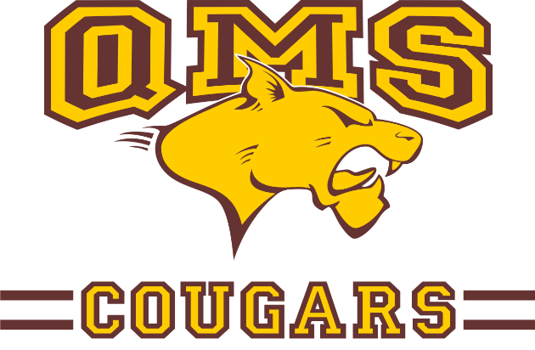
Quebec City Educational Tour

Quispamsis Middle School

Wednesday, June 13th – Saturday, June 16th, 2018

Wednesday June 13th

7:00 Depart on a locally chartered luxury coaches. Enjoy a movie during the trip.
11:00 Stop for quick lunch break in Edmundston. (own expense)
14:00 Meet your guides at Holiday Inn Express (Ave des Hôtels) and head to your first activity.
14:30 Visit the incredible Quebec City Aquarium. Get up close to the animals by following a guide on a 2 hour tour and experience first-hand the various marine life: seals, Polar bears, touch tank, etc.
16:30 Great start! Head to the hotel for check-in: Hotel Dauphin
18:00 Enjoy a nice buffet at Tomas Tam’s
20:00-20:15 Board the Louis Joliet cruise boat for a dance cruise!
20:30 Enjoy 2 hours of your favourite hits as you cruise along the St Lawrence River. Imagine - a school dance on the water!
22:30 What a day! Return to the hotel for a good night’s sleep.

Thursday June 14th

7:30-8:30 Breakfast at the hotel. Orientation with the guide. This morning, we explore Old Quebec and the city’s military history.
8:45 Leave the hotel for the first activity.
9:15 Welcome to Old Quebec – UNESCO World Heritage Site!
Embark on a very complete walking tour of Old Quebec: start in the Lower Town – Le Quartier Petit Champlain, one of the oldest commercial districts in North America; Place Royal, the birthplace of New France. Continue the tour in Upper Town – admire the Château Frontenac and much more!
11:00 Now it’s your turn to explore Old Quebec’s winding streets and shops in small groups. Take the time to have lunch at a bakery or café – or maybe try the poutine at Ashton’s (own expense).
13:15 Leave Old Quebec on the buses.
Group 1
13:30 Visit the grounds of the Quebec Legislature. Learn about the key people in the history of Quebec and Canada – represented as statues on the beautiful building’s facade. Take a picture in front of the Tourny Fountain – a gift to the city for its 400th anniversary.
14:00 Visit the Quebec City Observatory and learn about the importance of the geography to the success of Quebec City’s development (guided visit).
15:00 Make your way on foot to Old Quebec for your next activity.
15:30 Have a great time at the IMPROV! Learn this fun acting technique and have a hilarious time!
16:30 That was great – Hungry? Let’s go.
Group 2
13:30 Have a great time at the IMPROV! Learn this fun acting technique and have a hilarious time!
15:00 Visit the Quebec City Observatory, learn about the importance of the geography to the success of Quebec City’s development.
16:00 On your way to supper, visit the grounds of the Quebec Legislature. Learn about the key people in the history of Quebec and Canada – represented as statues on the beautiful building’s facade. Take a picture in front of the Tourny Fountain – a gift to the city for its 400th anniversary.
16:30 That was great.
Both groups

16:30 Enjoy a nice buffet supper together at Vieille Maison du Spagetti..

18:00 Run away to the Circus! Explore the circus arts at the famous Quebec Circus School! This is an amazing activity that will allow you to bring out your inner circus performer!
21:00 What a day! Return to the hotel for a good night’s sleep – big morning coming up.

Friday June 15th

7:30-8:30 Breakfast at the hotel.
8:30 Ready? Let’s go!
Bus 1
9:15 Take the Cable Car up from the base and enjoy the view from 85-meter above as you see the Montmorency Falls up close. Cross the suspension bridge for the best view. Then meet your bus again near the Manoir.
11:00 Walk around the incredible Ste Anne’s Basilica – this structure will leave you in awe! Admire 8-the mosaics, the reproduction of the Michelangelo’s Pieta, the stained-glass windows and much more. Check out the embossed copper on the front doors – look familiar?
12:00 Visit the Albert Gilles Copper Museum. Learn about the art of embossed copper and then try it out for yourself and bring home your own hand-made souvenir.
13:00 Head to the Les Galleries de la Capitale shopping mall.
13:30 Have fun at the indoor amusement park and practise your French looking for last-minute souvenirs. Don’t forget to grab lunch at the food court. (own expense)
Bus 2
9:15 Walk around the incredible Ste Anne’s Basilica – this structure will leave you in awe! Admire 8-the mosaics, the reproduction of the Michelangelo’s Pieta, the stained-glass windows and much more. Check out the embossed copper on the front doors – look familiar?
10:00 Visit the Albert Gilles Copper Museum. Learn about the art of embossed copper and then try it out for yourself and bring home your own hand-made souvenir.
11:30 Take the Cable Car up from the base and enjoy the view from 85-meter above as you see the Montmorency Falls up close. Cross the suspension bridge for the best view. Then meet your bus again near the Manoir.
13:00 Head to the Les Galleries de la Capitale shopping mall.
13:30 Have fun at the indoor amusement park and practise your French looking for last-minute souvenirs. Don’t forget to grab lunch at the food court. (own expense)

15:30 Head back to the hotel to drop off your things and get ready for the evening activity.

16:20 Ready? Let’s go!
18:30 Dance a jig, eat traditional Quebec food and satisfy your sweet tooth at the Cabane à sucre! (Érablière Lac Beauport)
20:30 What a great night. Head back to the hotel for a good night’s sleep.

Saturday June 16th

7:30-8:30 Breakfast at the hotel. Overview of the day and check out of the hotel.
9:00 Don’t forget your gym gear – we’re heading to Roc Gym!
9:30 Check out what it takes to climb Mount Everest – then try it yourself at this amazing indoor climbing centre. This activity will bring you to new heights.
12:30 Time to head home – it’s been great! See you next year!! Lunch and supper on the road (own expense)
22:00 Approximate time of arrival home.

Educational Tour Partnership Agreement

For:
Quispamsis Middle School
189 Pettingill Rd, Quispamsis, NB E2E 3S8

Proposed tour dates:

Wednesday, June 13 – Saturday, June 16, 2018

Tour Destination:

Quebec City

This quote includes:

- 3 breakfasts & 3 suppers;
- A high quality 3-4-star hotel, including evening security from 10:30 pm – 4:00 am.
- 56-seat luxury coaches;
- Guide and driver tips;
- 1 tour director per bus – he/she will join the group at the destination city and participate in all activities, including overnight stays at the hotel. However, the tour director(s) will be available for emergencies only from 11:00 pm – 8:00 am;
- All activities on the tour itinerary except those mentioned “own expense”;
- 4 students/hotel room & 2 chaperones/hotel room;
- In-class presentation to students in the fall;
- For each participant, one free presentation of pictures and videos set to music on a USB key

*In order to maintain the lowest cost possible, it is important to maximize the number of students per bus.
With 56-seat coaches, the usual numbers are: 50 paying students, 5 free chaperones and 1 tour director

**It is up to the school to determine the student-chaperone ratio, but Bon Vivant Educational Tours suggests 10:1 and will offer one free adult chaperone spot per 10 paying students.

The final cost Includes gratuities for tour directors and drivers.

Representative for Quispamsis Middle School Representative for Bon Vivant Educational Tours

Mrs. Shawna Spinks, Vice Principal Mr. Patrick Hurley, Director

